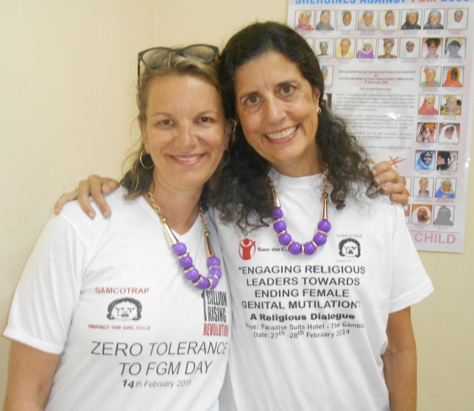
Nancy Peddle, Ph.D.
Figure 1 Vicki Browne and Nancy Peddle in The Gambia working to end FGM
Nancy Peddle, Ph.D. is the Founder and Executive Director of INGO LemonAid Fund (1999), working with individuals who have experienced injustices who want to improve their lives and those of their families and communities. LemonAid Fund focus is in Sierra Leone and West Africa. Dr. Peddle is also an Adjunct Faculty at The Chicago School of Professional Psychology with the International Psychology PhD program (2011) and a Wellness Coach. Her expertise has taken her to more than 25 countries and many areas of the US, many of which were war-torn (Sierra Leone, Kosovo, Middle-East), immersed in a natural disaster (Aceh, Indonesia), or coping with community violence (Chicago, Rosebud Reservation). She has expertise in leadership, early childhood, child protection, women’s issues, community-based programs, systems, participatory research, trauma, and psychosocial needs of children. Her current area of focus along with research is in building systems, addressing Female Genital Mutilation (FGM) issues, forgiveness, well-being, and education. She was a Research Fellow at Prevent Child Abuse America and was the first Executive Director for the International Society for the Prevention of Child Abuse and Neglect. She has lived the experiences, published extensively, and presents worldwide.
Dr. Peddle is educated in human organization and development at Fielding Graduate Institute (MA, PhD) in early childhood development at Bank Street College (MS) and a Bachelors in Social Work from Western Illinois University. In addition, she has certificates in business administration from the University of Illinois at Chicago, forgiveness from Stanford University, Wellness Coach from International Association for Wellness Professionals, trust in organizations, participatory action research, and spiritual areas. Her dissertation was on the role of forgiveness in trauma healing/recovery in a selected group of refugees in the Chicagoland area.

Vicki Browne RN, BSN, OCN
Vicki Browne RN is a register oncology nurse (1984), an Adjunct Faculty with The Chicago School of Professional Psychology (TCSPP) with the International Psychology PhD program (2013) and a volunteer for the LemonAid Fund (2000), working with individuals who have experienced injustices who want to improve their lives and those of their families and communities. She has led 6 Study Abroad/Field Experiences with the forgiveness work as a core tenant of the curriculum for TCSPP. Ms. Brownes’ volunteer and faculty work has focused on organizational development in developing countries and has included training and research in forgiveness, well-being, female genital mutilation and education. She is trained as an oncology nurse and is experienced in the psychosocial aspects of people who are dealing with cancer. She earned her BSN from the University of Illinois.

